Report for Assignment 2
PRM v.s. RRT

Case1 : a simple map
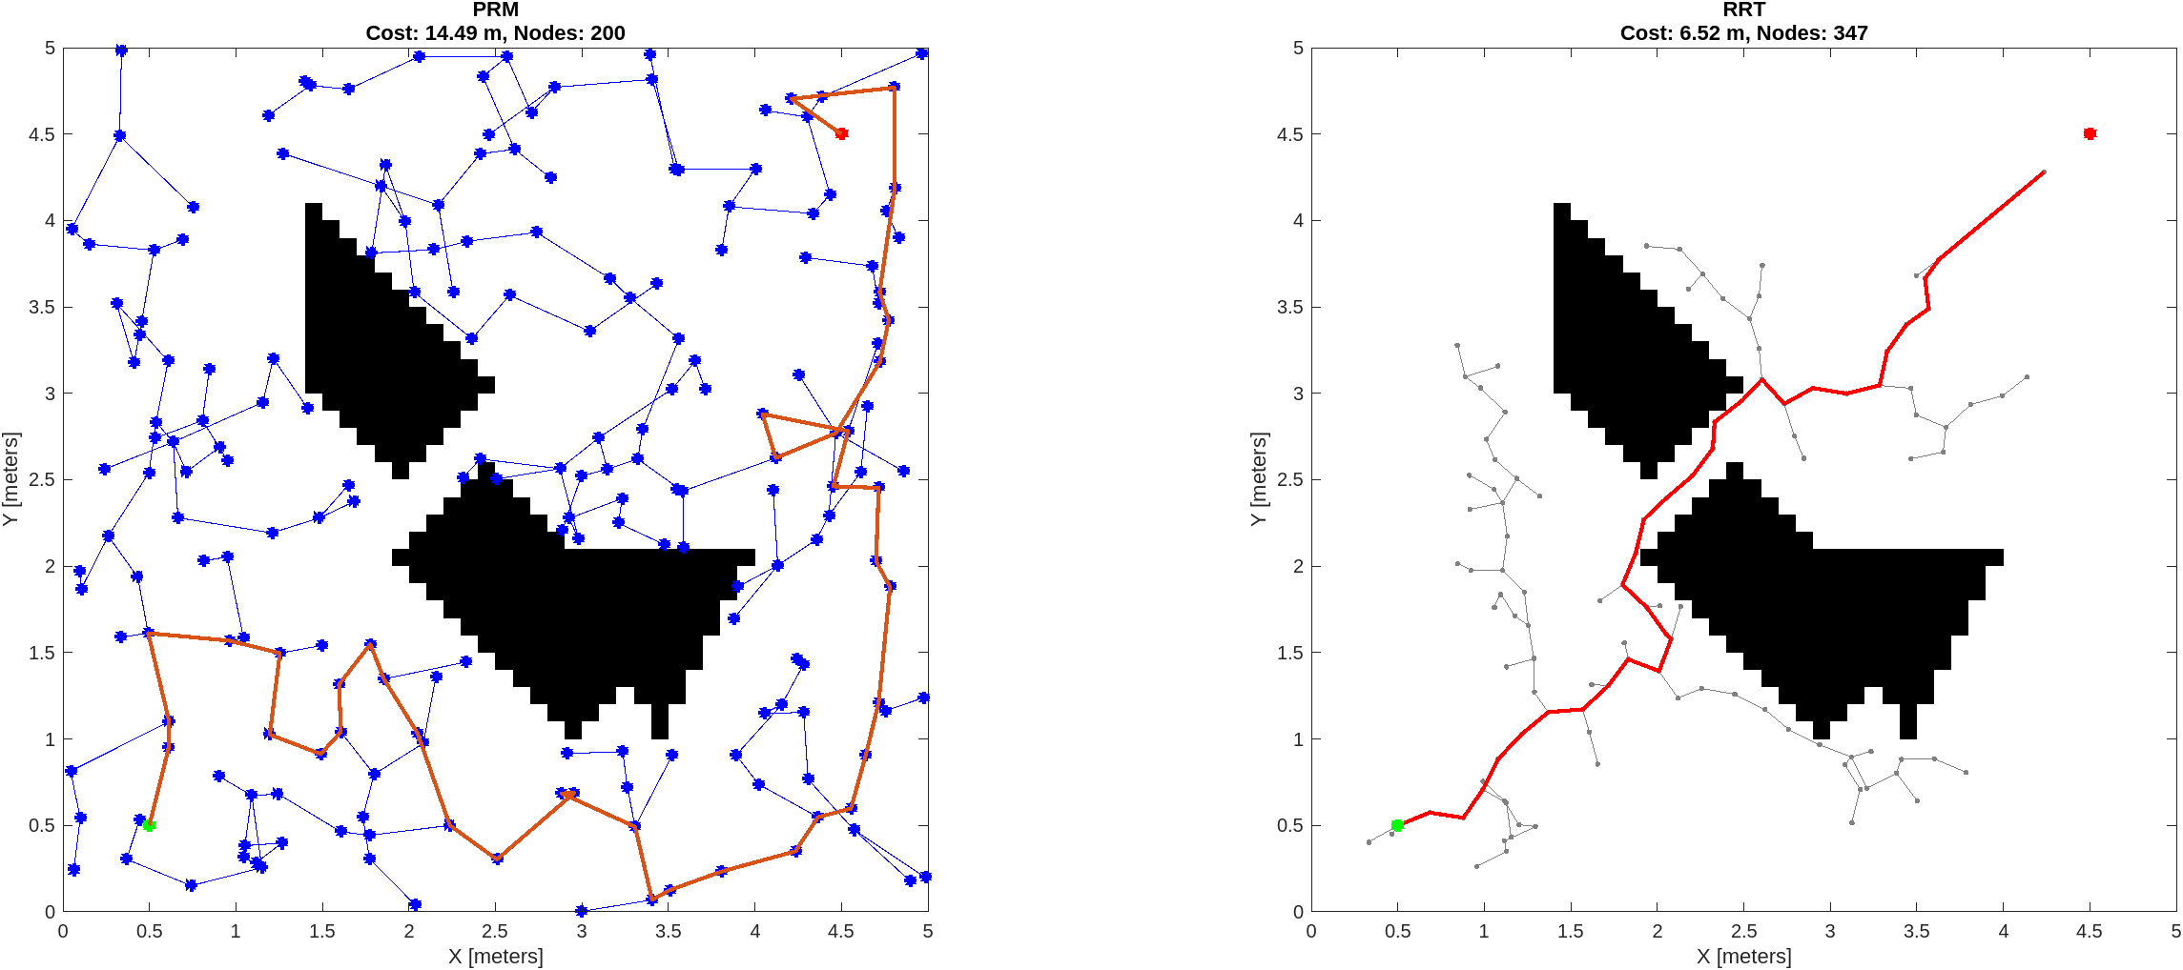
Case2 : a cluttered map
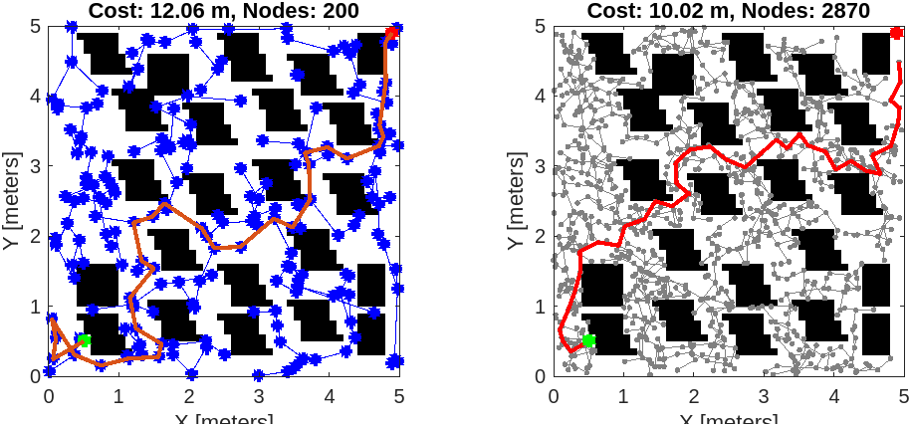
Answers to the questions:
- RRT is much more superior to PRM; this is because PRM heavily relies on doing the pre-computation of sampling over all the map, and this heavily dependent on the sampling strategy (trying to sample inside the passage, to evade the narrow passage problem), whereas RRT focuses locally around the current state at hand.

In the end we see that sometimes having partial knowledge of the map is beneficial (in the case of RRT)

- PRM has predetermined fixed parameter that controls the number of nodes to build the roadmap upon, so in comparison with RRT which tries to be parsimonious in the usage of nodes, PRM has a larger path than RRT.

- we can hand-tailor sampling strategies custom made depending on the context of application.
References:
- Their majesty LLMs :) (ChatGPT, Grok), at the beginning of the assignment, then decided to use just for map generation and plotting
- The valuable Matlab tutorials on path planning:
- https://fr.mathworks.com/help/nav/motion-planning.html?s_tid=CRUX_lftnav
- https://www.mathworks.com/help/nav/ref/plannerrrt.html
- https://www.mathworks.com/help/nav/ref/plannerprm.html
- https://fr.mathworks.com/help/nav/ref/statesamplergaussian.html#d126e139913
- https://fr.mathworks.com/help/nav/ref/validatoroccupancymap.html

